WWW.REBELCHOC.COM

FRONT PAGE
TO BE REMOVED
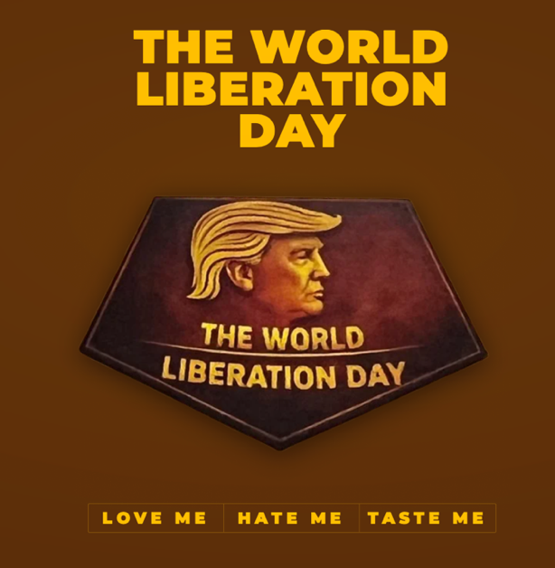

USE THIS NEW PHOTO TO START THE PAGE

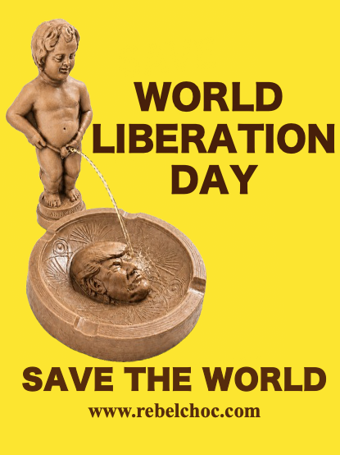

NARRATIVE BELLOW IN BIG FONT
LAUGH - REBEL - RESIST
REMOVE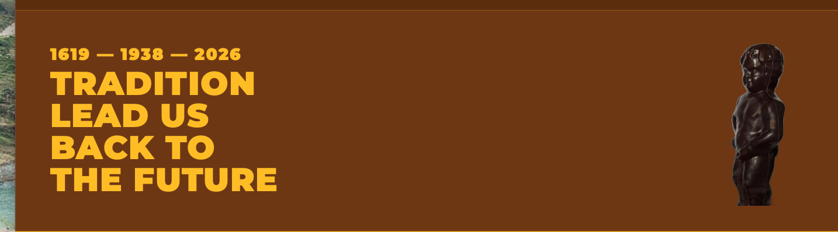

PHOTO 2

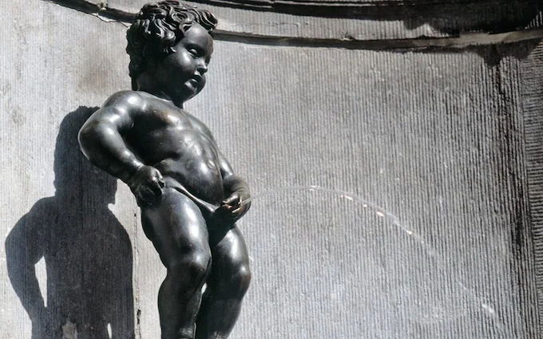
We might to altered with AI or just keep it

The Narrative in Big Fonts

1621
MANNEKEN PIS

SINCE 14TH CENTURY HE HAS BEEN THE MOST RENOWNED ART SYMBOL OF DEFEINCE REBELLION, RESISTANCE, REJECTION AND SATIRICAL HUMOUR!!

With humour we rebel, with humour we resist the lies, we reject the destruction, we support international and multilateral organisations that promote peace, solidarity and problem solving through negotiations

-------------------------------
Photo 3

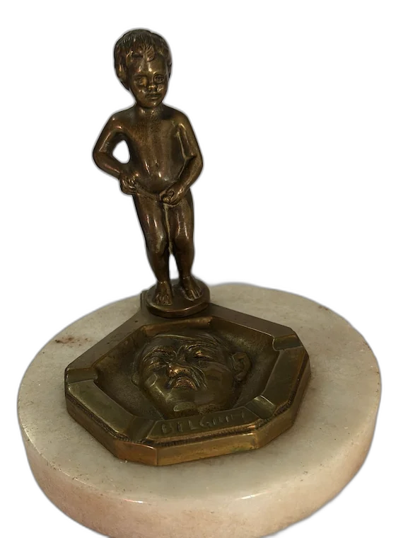

We need to make the image lighter and ideally making manneken pis to pee in Hitler’sface
NARRATIVE

MANNEKEN PIS NEVER FAILS AGAINST ANY BLINDFOLDED AUTHORITARIAN LEADERS

We will need to generate AI image as we need to have an arch with the following narrative

1619
Carlos V

1880
Leopold II

1933
- Hitler

2026
Against the
Blindness
Of Authoritarian
Leaders and “Influencers”

Photo 4

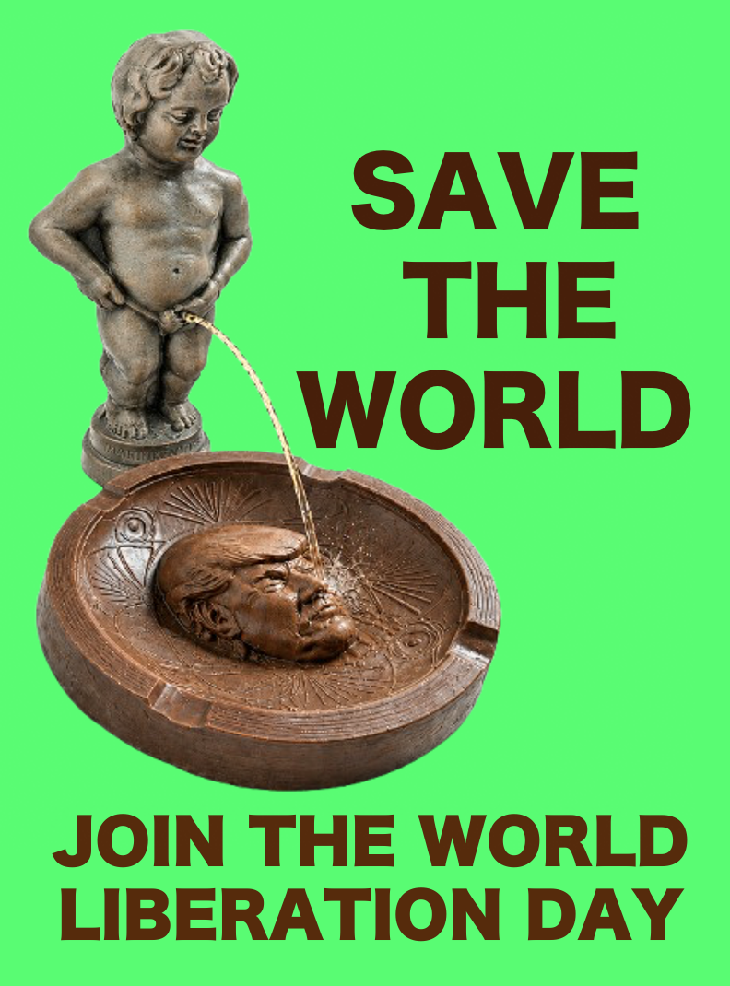

NARRATIVE

THE RE-EMERGENCE OF MANNEKEN PIS AS THE SYMBOL OF DEFIANCE, HUMOR AND WORLD RESISTANCE IS TO RISE HUMAN CONSCIOUNESS AGAINST THE POTENTIAL DESTRUCTION OF OUR PLANET, THROUGH UNCONTROLLED CLIMATE CHANGE AND LOST OF HUMAN SOLIDARITY IN SOLVING POLITICAL AND HUMAN CRISIS.

PLEASE REMOVE
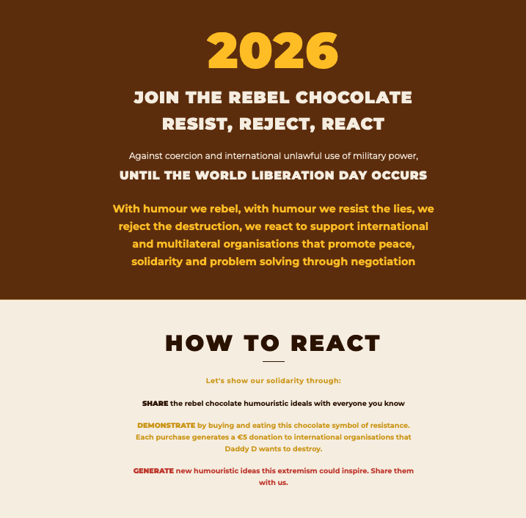

REMOVE
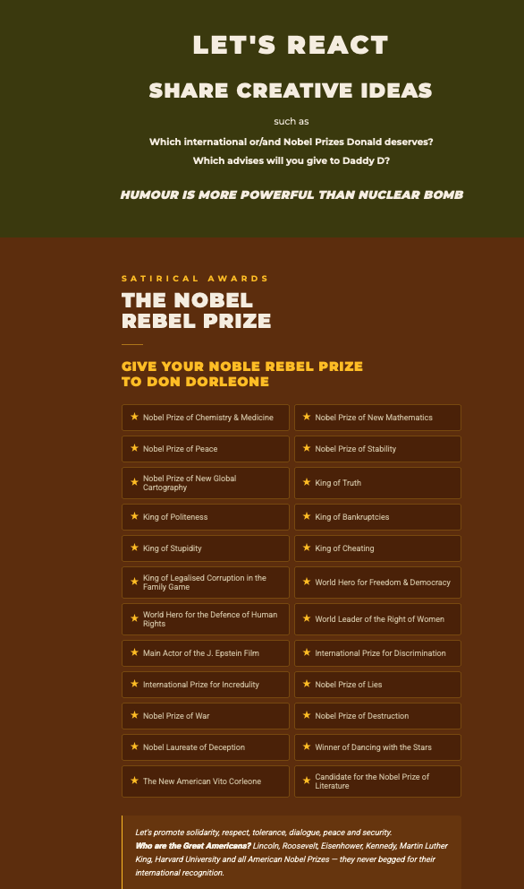

Photo / Narrative,

HOW TO JOIN THE WORLD LIBERATION DAY

BUY & WEAR A T-SHIRT
BUY REBEL CHOCOLATE IN BELGIUM
SHARE YOUR INCOME THROUGH DONATIONS

We will sell 4 different colours of T-Shirts
SEE PDF FILE with 4 T-Shirts in different colours
We will sell 2 sizes = Size M and Size L
We will use E-bay as the platform to sell the T-Shirts

ORDER NOW
needs to be rebuilt THIS PART OF THE WEBPAGE

